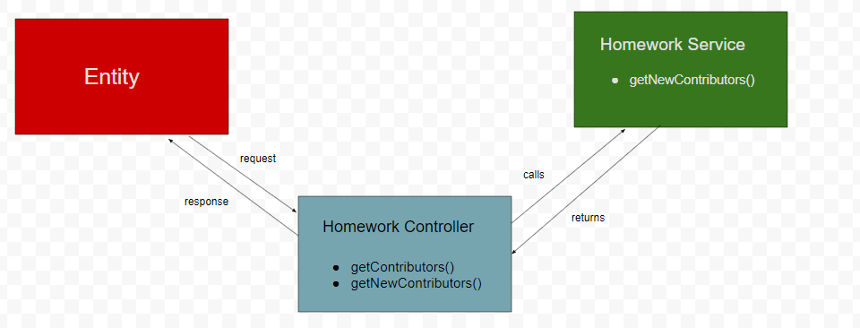

**getContributors() -** gets all the contributors to a repository and along with that specifies the date of initial commit. We have used the Octonode api client to access Github Api v3.

**getNewContributors() -** gets all the new contributors to a repository and the date they started contributing to the repository.

**Tools and Technologies:**

* NEST JS
* GITHUB API V3
* OCTONODE

